1. **INTRODUCTION**

**1.1 Background**

The population of the world is multiplying with each coming year and so are the diseases and health issues. With an increase in the population there is an increase in the need of blood. The growing population of the world results in a lot of potential blood donors. But in spite of this not more than 10% of the total world population participates in blood donation. With the growing population and the advancement in medical science the demand for blood has also increased. Due to the lack of communication between the blood donors and the blood recipients, most of the patients in need of blood do not get blood on time and hence lose their lives. There is a dire need of synchronization between the blood donors and hospitals and the blood banks. This improper management of blood leads to wastage of the available blood inventory. Improper communication and synchronization between the blood banks and hospitals leads to wastage of the blood available. These problems can be dealt with by automating the existing manual blood bank management system. A high-end, efficient, highly available and scalable system has to be developed to bridge the gap between the donors and the recipients and to reduce the efforts required to search for blood donors. At present, the public can only know about the blood donation events through conventional media means such as radio, newspaper or television advertisements. There is no information regarding the blood donation programs available on any of the portal. The current system that is using by the blood bank is manual system. With the manual system, there are problems in managing the donors' records. The records of the donor might not be kept safely and there might be missing of donor's records due to human error or disasters. Besides that, errors might occur when the staffs keeps more than one record for the same donor. There is no centralized database of volunteer donors. So, it becomes really tedious for a person to search blood in case of emergency. The only option is to manually search and match donors and then make phone calls to every donor. There is also no centralized database used to keep the donors' records. Each bank is having their own records of donors. If a donor makes donation in different hospital, no previous records can be traced except if the donor brings along the donation certificate. Hence, the donor is considered to be a first-timer if they make blood donation in a new place. Without an automated management system, there are also problems in keeping track of the actual amount of each and every blood type in the blood bank. In addition, there is also no alert available when the blood quantity is below its par level or when the blood in the bank has expired.

**1.2 Objective**

The main objective of this application is to automate the complete operations of the blood bank. They need maintain hundreds of thousands of records. Also searching should be very faster so they can find required details instantly.

* To allow the probable recipients to make search and match the volunteer donors, and make request for the blood.
* To provide an efficient donor to user.
* To provide immediate storage and retrieval of data and information.
* User friendly system.
* Easy to use and efficient computerized system.
* To develop an accurate and flexible system, it will eliminate
* Less chances of information leakage. Provides security to data by using login & password.

**1.3 Proposed System and Scope**

**1.3.1 Proposed System**

The purpose of the smart blood donor system is to simplify and automate the process of searching for blood in case of emergency and maintain the records of blood donors, recipients, blood donation programs and blood stocks in the bank. There is no centralized database of volunteer donors. So, it becomes really tedious for a person to search blood in case of emergency.

**1.3.2 Scope**

**The main Scope of study-**

**Scope:**

The Scope of the project is that in a very short span it provides user with many facilities. It provides an elegant management of blood, list of hospitals, blood banks and donors online. The main purpose of this project is to interconnect all the blood banks, hospitals, donors into a single network, validation, store various data and information of blood and health of each individual. This system is used to store data over a centralized server which consists of database where the individuals’ information cannot be accessed by a third party.

User can find their specific blood group; User can find donors contact details. User can communicate with donor by making call or message directly to the donors by using our application.

**Modules:**

There are some module used in the system which are as follows,

* **User:** In user module, Registered user can login using there login name and password. After login user can search for donor as per there requirement. After getting result of search user can send the request for donor. After getting the acceptance of request user get SMS and all detail information about donor as well as donor also getting SMS and information about User. User also has facility to change their password.
* **Admin:** In admin module, admin get notification of user requests. Admin have rights to accept or reject request. Admin send the SMS after accepting the request of user to both user and donor. Admin can see the all registered users list.

**2.REQUIREMENT AND ANALYSIS**

**2.1 Problem Definition**

Carrying out tag mining is a challenging problem because of the following reasons.

* Due to insufficient data, the proposed scheme will not work.
* The concepts stored will be in the form of dataset, where the relation between dataset is not associated properly.

**2.2 Requirements Specification**

A requirement is a feature that must be included in the system. Before the actual design and implementation starts, getting to know the system to be implemented is of prime important. It specifies the list of features that is to be included and the functionalities of these features.

Talking these into mind we have emphasize on the following:

* User interaction with the system.
* The inputs to the system
* The output expected from system.

**2.3 Planning and Scheduling**

* Design of the process: 15 days.
* Coding: 20 days.
* Testing: 30 days.
* Analysis of Bugs: 20 days.

**2.4 Software and Hardware Requirements**

* **Hardware Requirements :-**

**Processor : -** Dual Core or more.

**RAM : -** 1GB

**Hard Disk : -** 40 GB

**Display Type : -** SVGA Color Monitor

**Keyboard**  **: -** Enhanced 104 Standard

**Mouse**  **: -** PS/2 2Button, USB

* **Software Requirements :-**

**Operating System :** windows 7, windows 8 and Upper version

**Web Browser :** IE6 or upwards, Google Chrome, Mozilla Firefox

**Web Server :**  IIS 7.0

**IDE Tools :** Microsoft Visual Studio

**Front End :** Asp.Net

**Database/Back End :** Microsoft SQL Server

**Language Structure :** C#

**2.5 Feasibility Study**

The feasibility of the project is analyzed in this phase and business proposal is put forth with a very general plan for the project and some cost estimates. During system analysis the feasibility study of the proposed system is to be carried out. This is to ensure that the proposed system is not a burden to the company. For feasibility analysis, some understanding of the major requirements for the system is essential.

Three key considerations involved in the feasibility analysis are

* **Economical Feasibility**
* **Technical Feasibility**
* **Social Feasibility**

**2.5.1 Economical Feasibility**

This study is carried out to check the economic impact that the system will have on the organization. The amount of fund that the company can pour into the research and development of the system is limited. The expenditures must be justified. Thus the developed system as well within the budget and this was achieved because most of the technologies used are freely available. Only the customized products had to be purchased.

**2.5.2 Technical Feasibility**

This study is carried out to check the technical feasibility, that is, the technical requirements of the system. Any system developed must not have a high demand on the available technical resources. This will lead to high demands on the available technical resources. This will lead to high demands being placed on the client. The developed system must have a modest requirement, as only minimal or null changes are required for implementing this system.

**2.5.3 Social Feasibility**

The aspect of study is to check the level of acceptance of the system by the user. This includes the process of training the user to use the system efficiently. The user must not feel threatened by the system, instead must accept it as a necessity. The level of acceptance by the users solely depends on the methods that are employed to educate the user about the system and to make him familiar with it. His level of confidence must be raised so that he is also able to make some constructive criticism, which is welcomed, as he is the final user of the system.

**Hardware used in this project is as follows-**

|  |  |
| --- | --- |
| **Components Required** | **Cost** |
| Intel Core i3 processor (CPU) or above. | Rs. 4000-5000 |
| RAM (minimum 512 MB) | Rs. 800-1000 |
| Hard Disk Space(160 GB) | Rs. 900-1000 |
| Monitor | Rs. 3000-4000 |
| Keyboard/Mouse | Rs. 500-600 |

Table no. 2.5.1 (a) Hardware used in this project

**Software used in this project is as follows-**

|  |  |
| --- | --- |
| **Software Required** | **Cost** |
| Operating system(Any) | Rs.10000-12000 |
| Visual Studio | 25000 |
| SQL Server | 15000 |

Table no. 2.5.1 (b) Software used in this project

**3.SURVEY OF TECHNOLOGIES**

**3.1 .Net Framework**

Microsoft .NET Framework is a complex technology that provides the infrastructure for building, running, and managing next generation applications. In a layered representation, the .NET Framework is a layer positioned between the Microsoft Windows operating system and your applications. .NET is a platform but also is defined as a technology because it is composed of several parts such as libraries, executable tools, and relationships and integrates with the operating system. Microsoft Visual Studio 2010 relies on the new version of the .NET Framework. Visual Basic 2010, C#, and F# 2010 are .NET languages that rely on and can build applications for the .NET Framework.

The .NET Framework is an application development platform that provides services for building, deploying, and running desktop, web, and phone applications and web services. It consists of two major components: the common language runtime (CLR), which provides memory management and other system services, and an extensive class library, which includes tested, reusable code for all major areas of application development.

**3.2 ASP.net**

ASP.NET is more than the next version of Active Server Pages (ASP); it provides a unified Web development model that includes the services necessary for developers to build enterprise-class Web applications. While ASP.NET is largely syntax compatible with ASP, it also provides a new programming model and infrastructure for more scalable and stable applications that help provide greater protection. You can feel free to augment your existing ASP applications by incrementally adding ASP.NET functionality to them.

ASP.NET is a compiled, .NET-based environment; you can author applications in any .NET compatible language, including Visual Basic .NET, C#, and JScript .NET. Additionally, the entire .NET Framework is available to any ASP.NET application. Developers can easily access the benefits of these technologies, which include the managed common language runtime environment, type safety, inheritance, and so on.

Web Forms allow you to build powerful forms-based Web pages. When building these pages, you can use ASP.NET server controls to create common UI elements, and program them for common tasks. These controls allow you to rapidly build a Web Form out of reusable built-in or custom components, simplifying the code of a page. For more information, see Web Forms Pages. For information on how to develop ASP.NET server controls, see Developing ASP.NET Server Controls.

An XML Web service provides the means to access server functionality remotely. Using XML Web services, businesses can expose programmatic interfaces to their data or business logic, which in turn can be obtained and manipulated by client and server applications. XML Web services enable the exchange of data in client-server or server-server scenarios, using standards like HTTP and XML messaging to move data across firewalls. XML Web services are not tied to a particular component technology or object-calling convention. As a result, programs written in any language, using any component model, and running on any operating system can access XML Web services. For more information, see XML Web Services Created Using ASP.NET and XML Web Service Clients.

Each of these models can take full advantage of all ASP.NET features, as well as the power of the .NET Framework and .NET Framework common language runtime. These features

* If you have ASP development skills, the new ASP.NET programming model will seem very familiar to you. However, the ASP.NET object model has changed significantly from ASP, making it more structured and object-oriented. Unfortunately this means that ASP.NET is not fully backward compatible; almost all existing ASP pages will have to be modified to some extent in order to run under ASP.NET. In addition, major changes to Visual Basic .NET mean that existing ASP pages written with Visual Basic Scripting Edition typically will not port directly to ASP.NET. In most cases, though, the necessary changes will involve only a few lines of code. For more information, see Migrating from ASP to ASP.NET.
* Accessing databases from ASP.NET applications is an often-used technique for displaying data to Web site visitors. ASP.NET makes it easier than ever to access databases for this purpose. It also allows you to manage the database from your code. For more information, see Accessing Data with ASP.NET.
* The .NET Framework and ASP.NET provide default authorization and authentication schemes for Web applications. You can easily remove, add to, or replace these schemes, depending upon the needs of your application. For more information, see Securing ASP.NET Web Applications.
* ASP.NET configuration settings are stored in XML-based files, which are human readable and writable. Each of your applications can have a distinct configuration file and you can extend the configuration scheme to suit your requirements. For more information, see ASP.NET Configuration.
* Applications are said to be running side by side when they are installed on the same computer but use different versions of the .NET Framework. To learn how to use different versions of ASP.NET for separate applications on your server, see Side-by-Side Support in ASP.NET.
* IIS 7.0 uses a new process model called worker process isolation mode, which is different from the process model used in previous versions of IIS. ASP.NET uses this process model by default when running on Windows Server 2003. For information about how to migrate ASP.NET process model settings to worker process isolation mode, see IIS 7.0 Application Isolation Modes.

**4.SYSTEM DESIGN**

**4.1 Program Flow Chart**

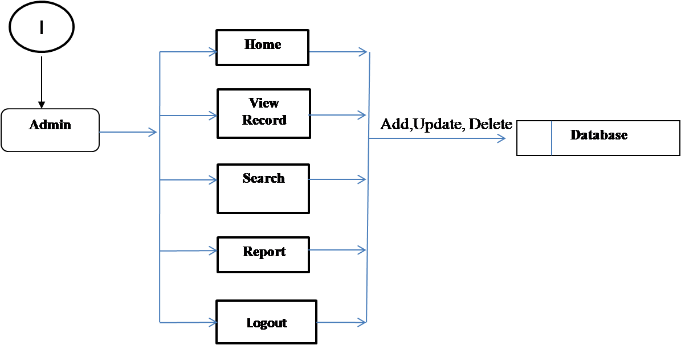

Fig 4.1 (a) Flowchart diagram

**4.2 Basic Modules**

There are some module used in the system which are as follows,

* **User:** In user module, Registered user can login using there login name and password. After login user can search for donor as per there requirement. After getting result of search user can send the request for donor. After getting the acceptance of request user get SMS and all detail information about donor as well as donor also getting SMS and information about User. User also has facility to change their password.
* **Admin:** In admin module, admin get notification of user requests. Admin have rights to accept or reject request. Admin send the SMS after accepting the request of user to both user and donor. Admin can see the all registered users list.

**4.3 Data Design-**

Data design is the first design activity, which results in fewer complexes, modular and efficient program structure. The information domain model developed during analysis phase is transformed into data structures needed for implementing the software.

**4.3.1Database Design:**

In this section we specify the various design features of our proposed system. Starting with the design of the database we gradually move towards speciation of how the input and output of the project is design and presented. This section also includes the data flow diagrams and the system flowcharts outlining the working of the entire program as a whole and also of the various modules involved in the program. Our project is proposed to manage the daily working of the website and the Login and Log Out of the user. As such we have included database which keeps the record of the user, all the updating and changes are done only to this database.

**Registration:**

The user’s record stored in the table as following structure:

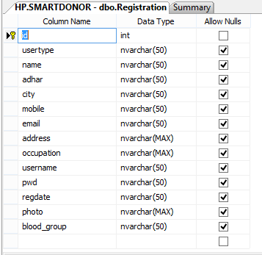

Table no. 4.3.1(a) Registration

**Request:**

The request record contains the following structure:

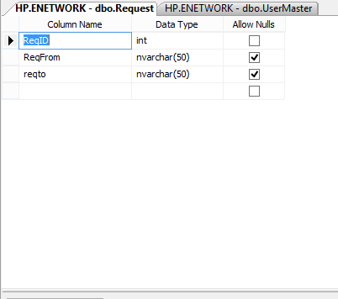

Table no. 4.3.1(b) Request

**AdharData:**

This table record contains following Structure:

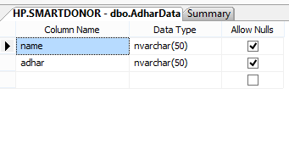

Table no. 4.3.1(c) AdharData

**4.4.2 Data Dictionary**

A data dictionary is a collection of descriptions of the data objects or items in a data model for the benefit of programmers and others who need to refer to them. A first step in analyzing a system of objects with which users interact is to identify each object and its relationship to other objects. This process is called data modeling and results in a picture of object relationships. After each data object or item is given a descriptive name, its relationship is described (or it becomes part of some structure that implicitly describes relationship), the type of data (such as text or image or binary value) is described, possible predefined values are listed, and a brief textual description is provided. This collection can be organized for reference into a book called a data dictionary.

When developing programs that use the data model, a data dictionary can be consulted to understand where a data item fits in the structure, what values it may contain, and basically what the data item means in real-world terms.

**4.3.3 Entity Relationship diagram:**

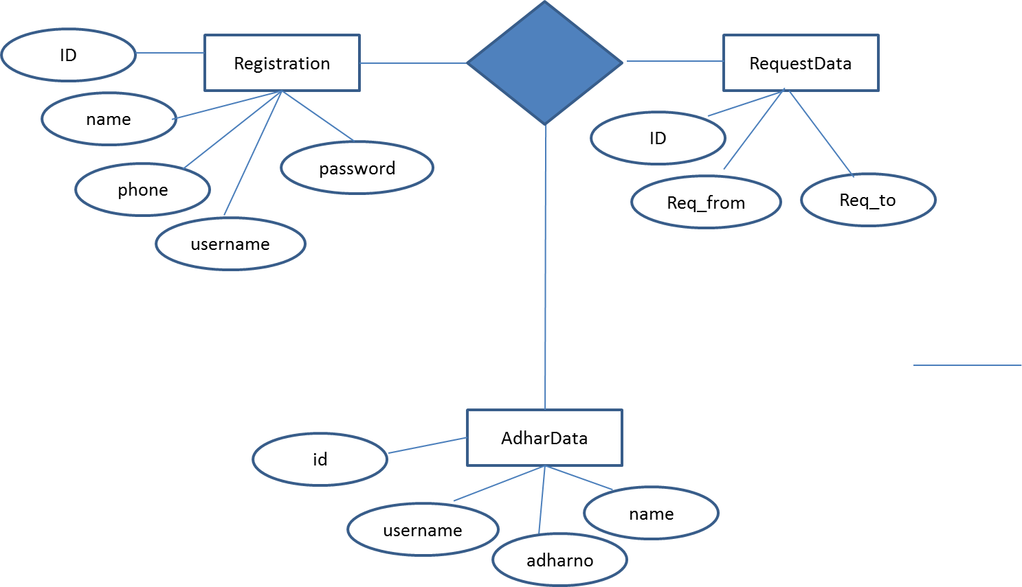

Fig 4.3.3(a) Entity Relationship diagram

**DFD**

* The Data Flow Diagram (DFD) is also called as bubble chart. It is a simple graphical formalism that can be used to represent a system in terms of input data to the system, various processing carried out on this data, and the output data is generated by this system.
* The data flow diagram (DFD) is one of the most important modeling tools. It is used to model the system components. These components are the system process, the data used by the process, an external entity that interacts with the system and the information flows in the system.
* DFD shows how the information moves through the system and how it is modified by a series of transformations. It is a graphical technique that depicts information flow and the transformations that are applied as data moves from input to output.
* DFD is also known as bubble chart. A DFD may be used to represent a system at any level of abstraction. DFD may be partitioned into levels that represent increasing information flow and functional detail.

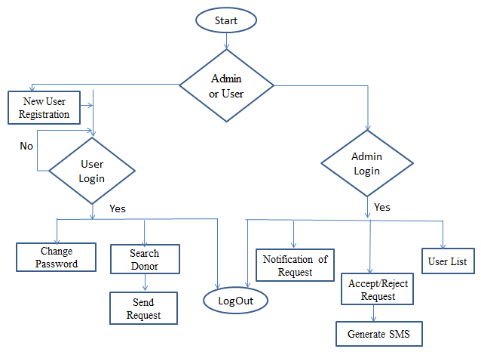

Fig. 4.3.3 (b) Data Flow Diagram

**4.4 UML Diagram-**

Unified Modeling Language (UML) is a graphical modeling language for describing; visualizing, projecting and documenting of object oriented systems. UML is used for modeling of organizations and their business processes, for development the big project, the complex software applications.

**4.4.1Hierarchy Diagram:**

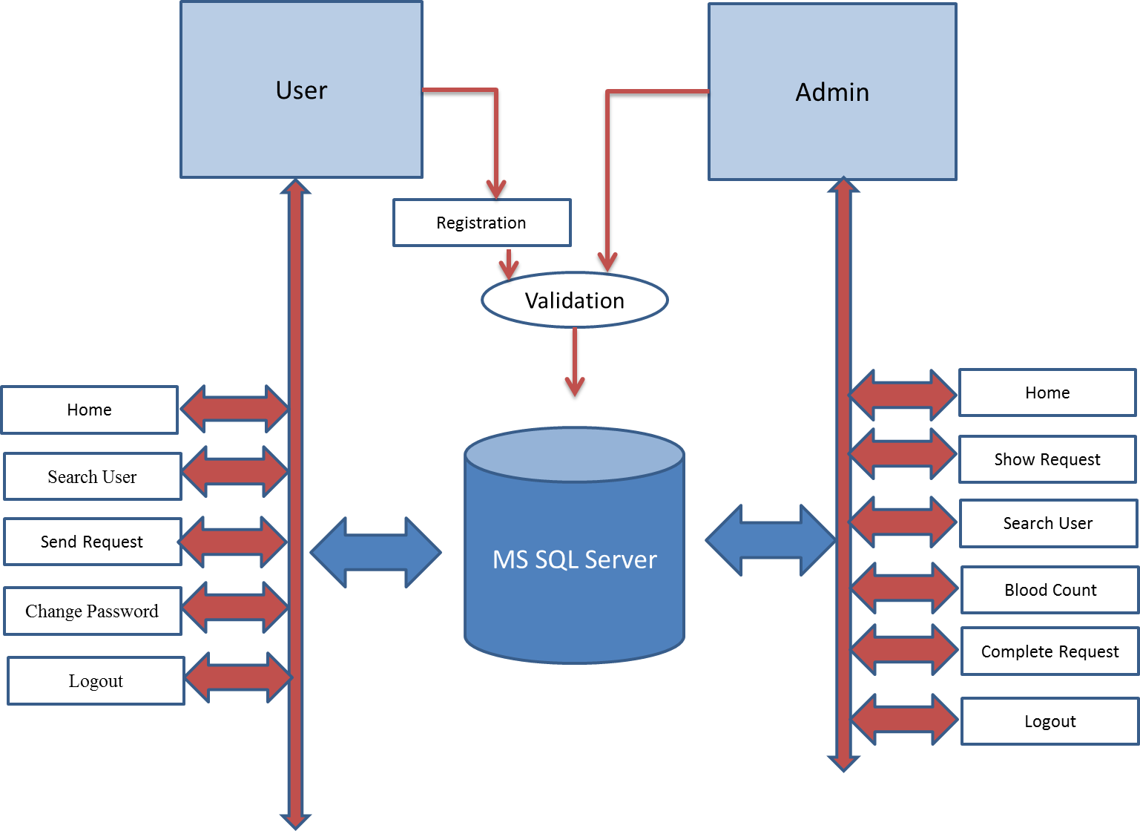

Fig 4.4.1(a) Hierarchy Diagram

**4.4.2 Use case Diagram:**

Diagrams of this type represent a list of operations performed by the system. Such diagrams are also called functional diagrams, as the list of the system's functions is created based on them, in accordance with the specified requirements. Use case diagrams are used to describe business processes in automated applications and to define requirement for software to be developed. They depict objects from the system and application domain as well as the tasks performed by them Use case diagram is one of the UML diagrams which specify actors and their roles in the system. There are the two use cases diagrams, first use case diagram for admin and second use case diagram for user such as,

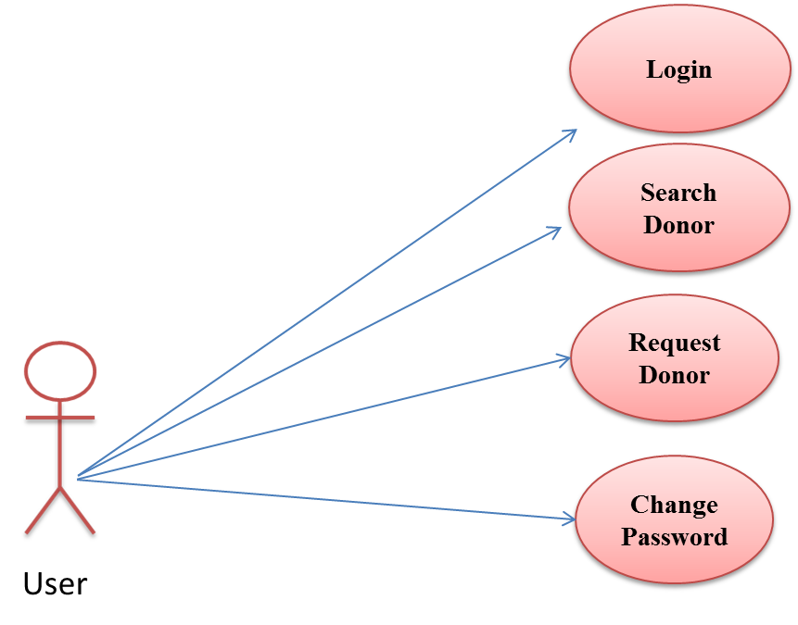

Fig 4.4.2 (a) use case Diagram for user

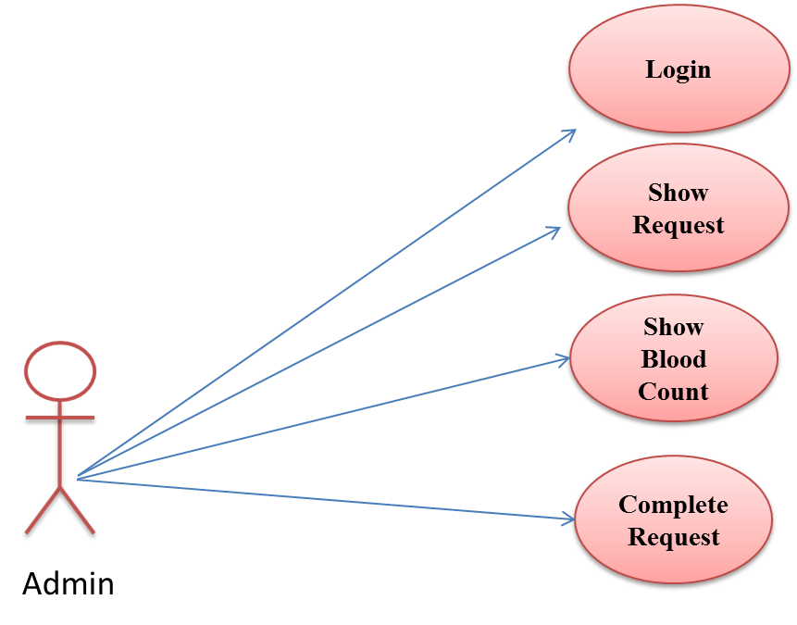

Fig 4.4.2 (b) use case Diagram for Admin

**4.4.3 Activity Diagram**

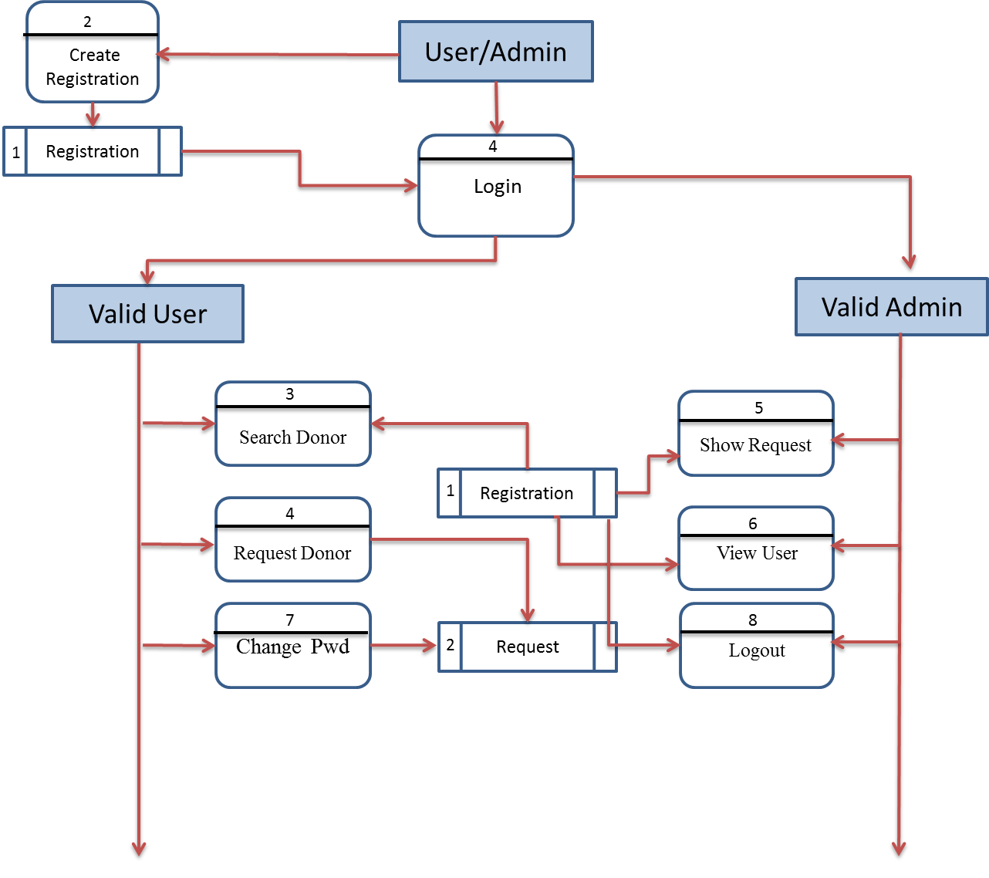

Fig 4.4.3 Activity Diagram

**4.4.4 Sequence Diagram**

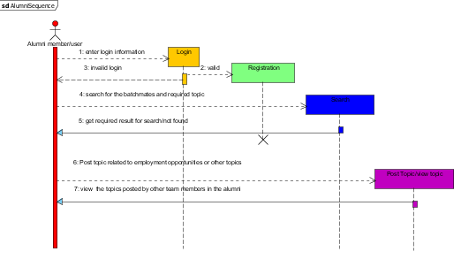

Fig 4.4.4 Sequence Diagram

**4.4.5 Server Deployment:**

UML diagrams of this type serve to analyze the hardware used in system implementations, interaction between the processor and other components. As a rule, such diagrams are used in the beginning of designing to determine the hardware configuration of the system.

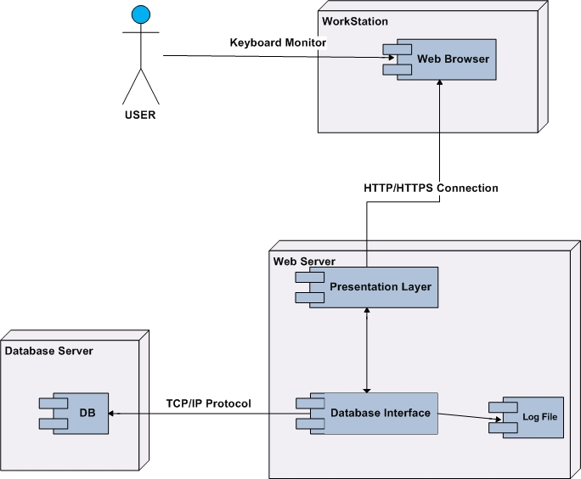

Fig 4.4.5 Server Deployment

**5.IMPLEMENTATION AND TESTING**

**5.1Coding & Designing-**

**Home Page**

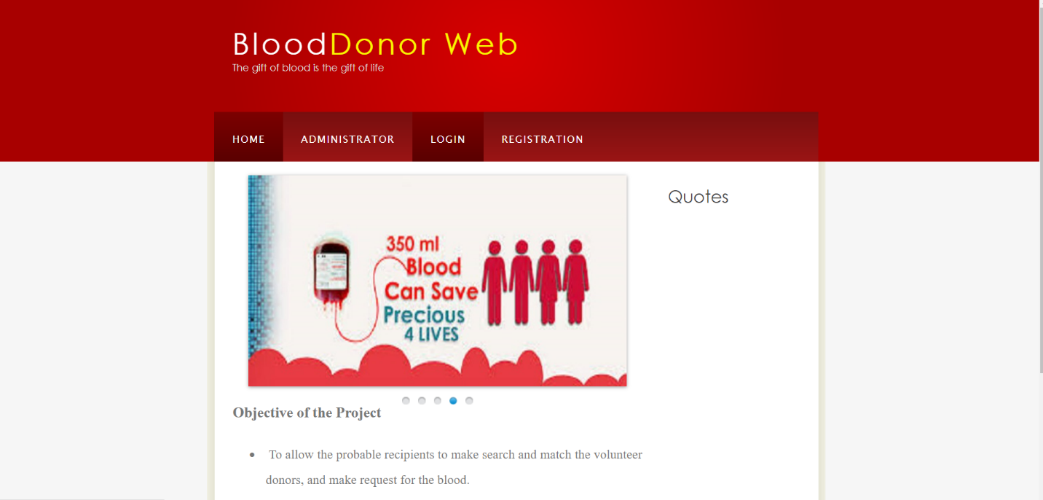

Screenshot: 5.1 (a) Home Page

**Login**

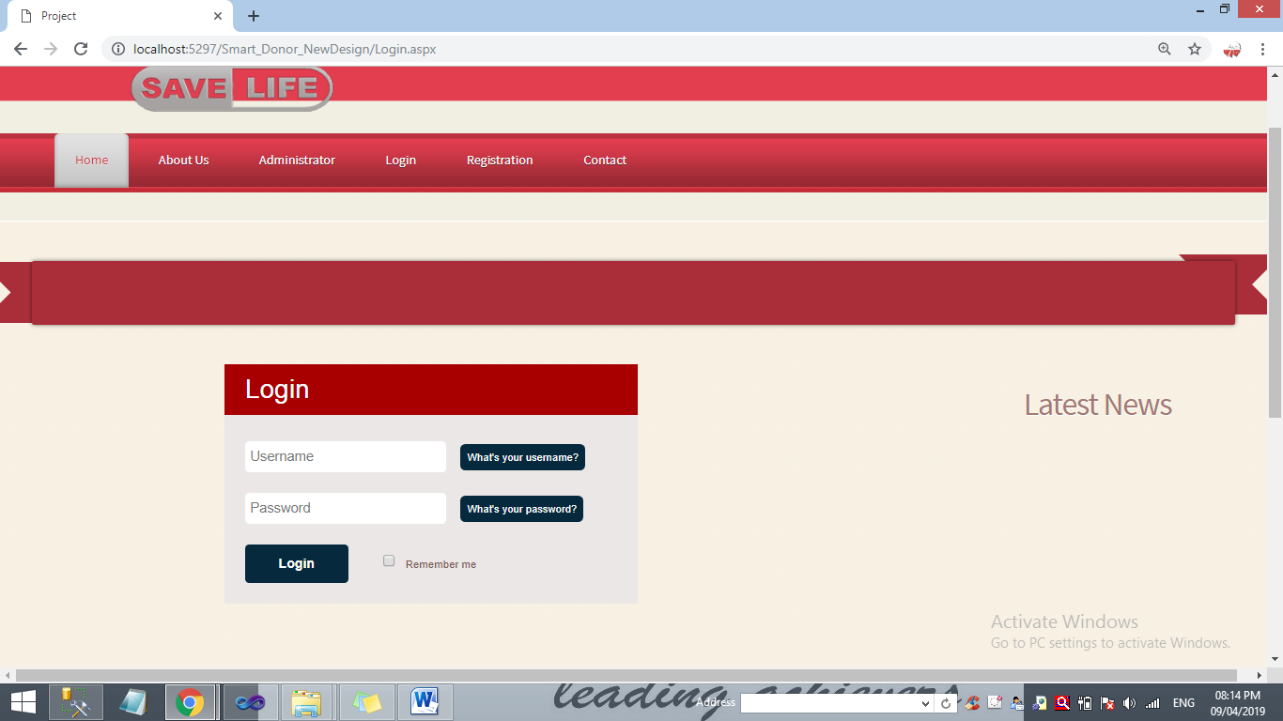

Screenshot: 5.1 (b) Login Page

**Registration Page**

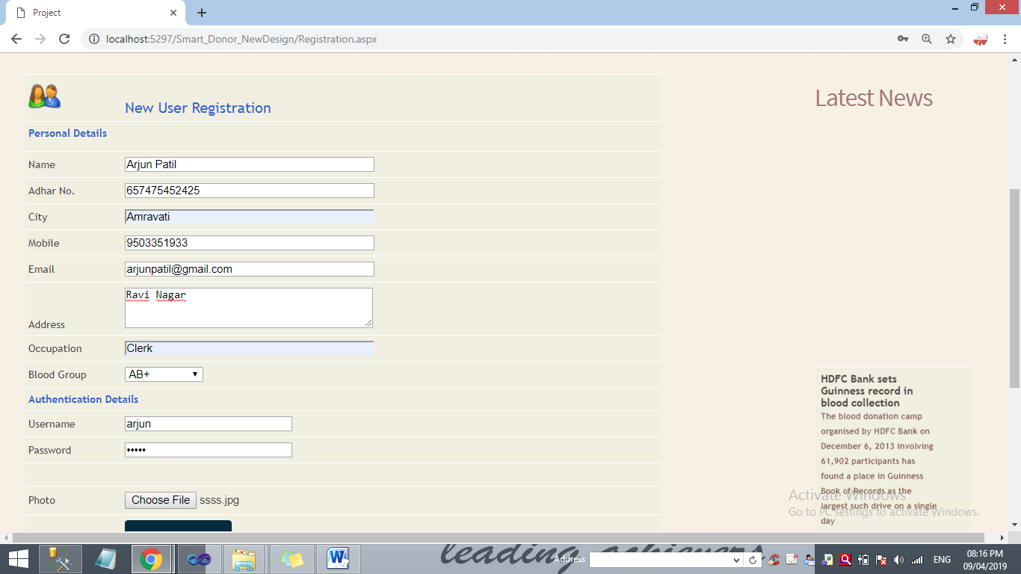

Screenshot: 5.1 (c) Registration

**After Registration**

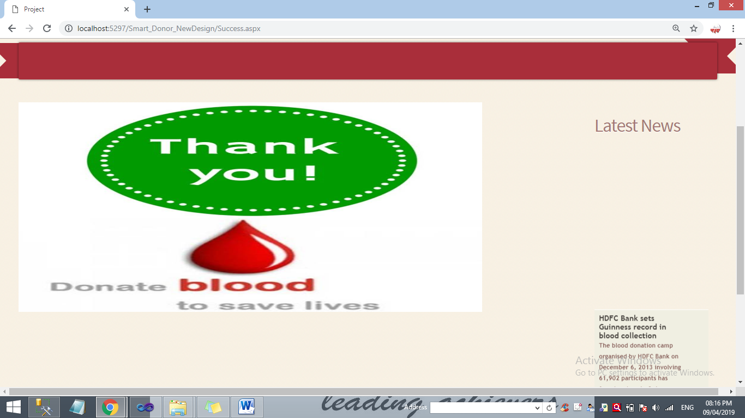

Screenshot: 5.1 (d)After Registration

**After Login**

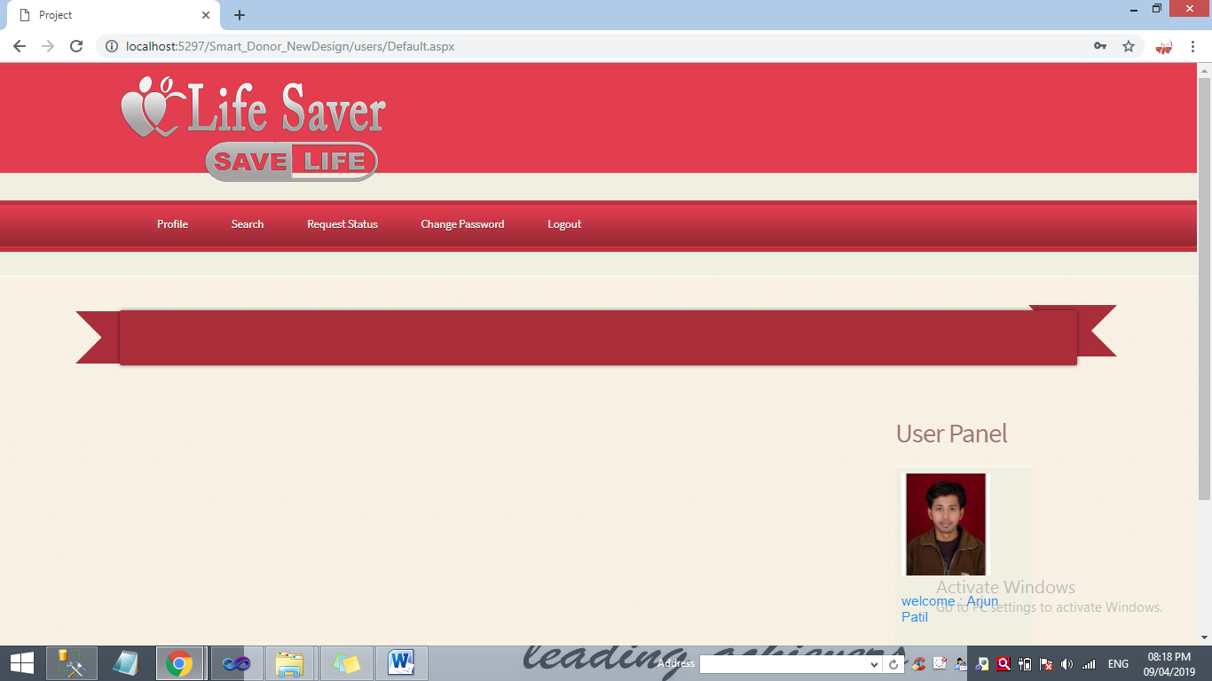

Screenshot: 5.1 (f)After Login Page

**Search**

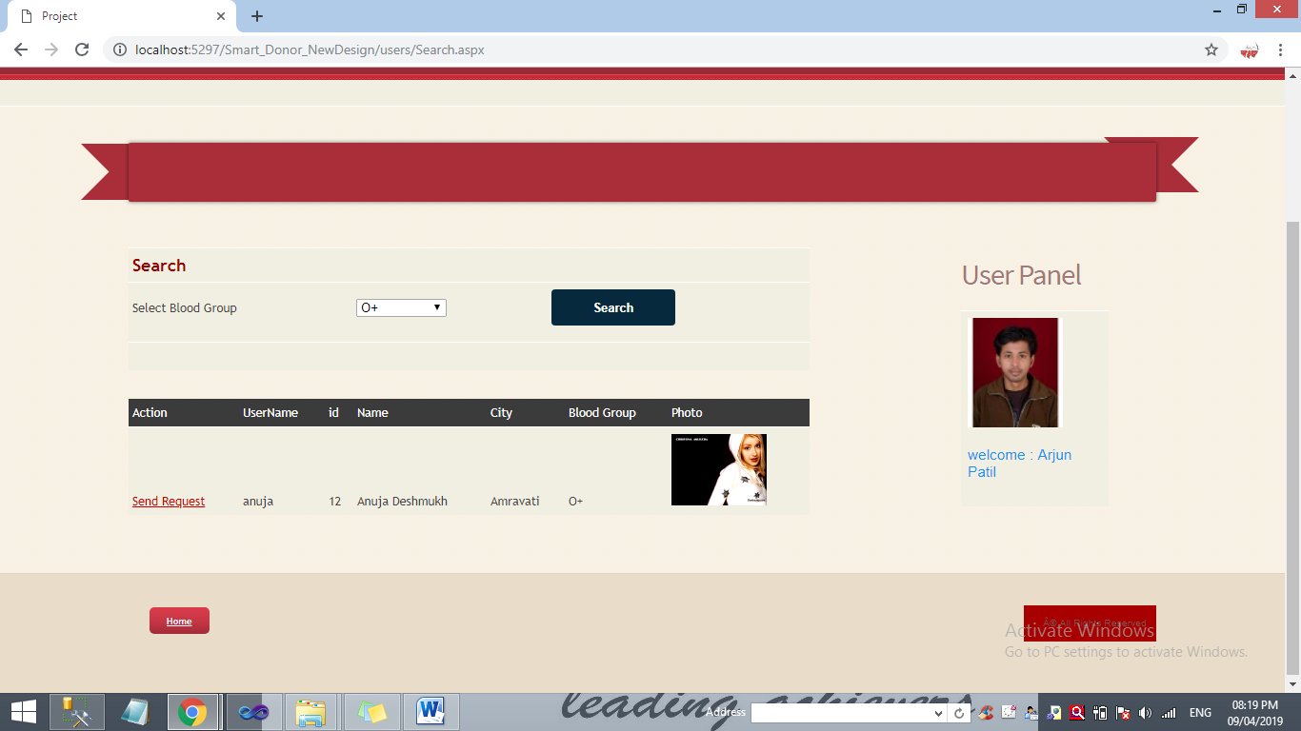

Screenshot: 5.1 (g)Search Page

**Change Password**

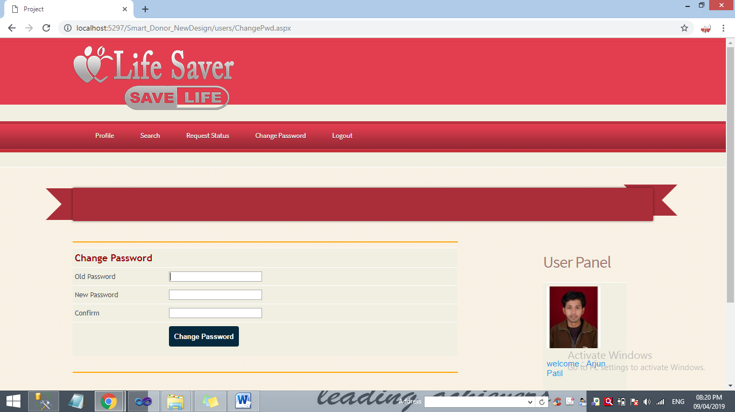

Screenshot: 5.1 (j) Change Password Page

**Admin Login**

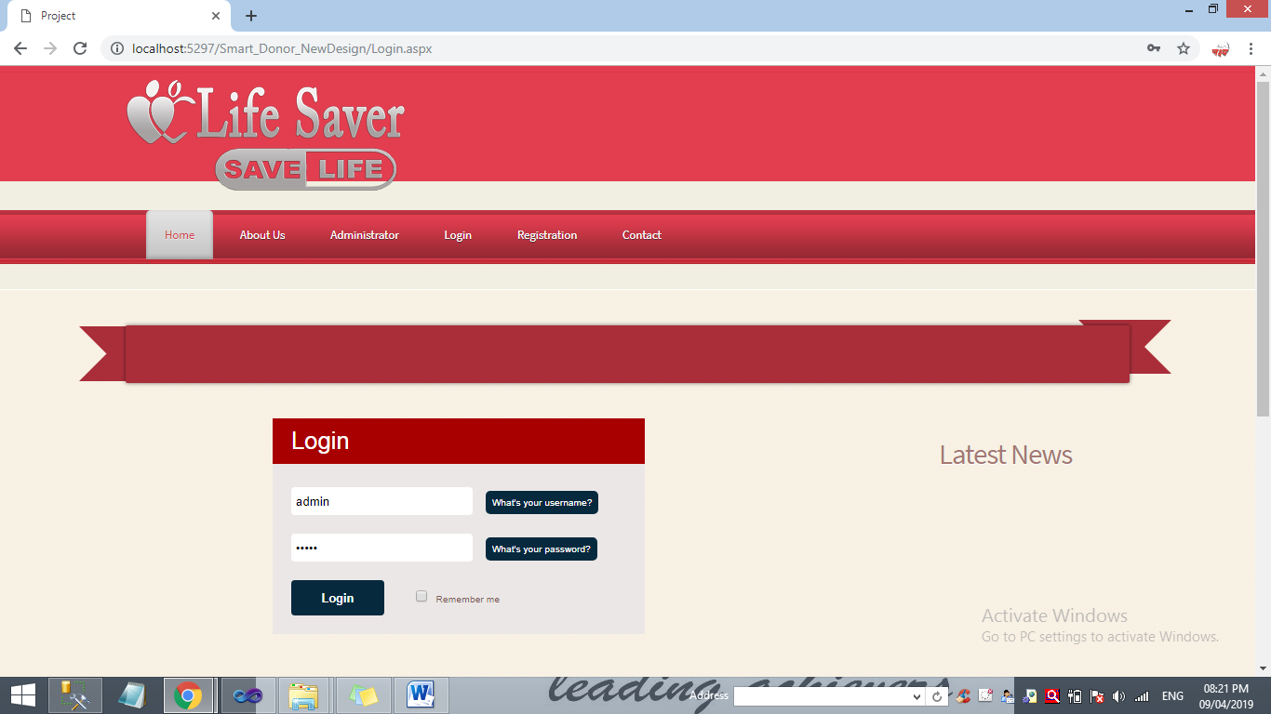

Screenshot: 5.1 (k)Admin Login Page

**After Admin Login**

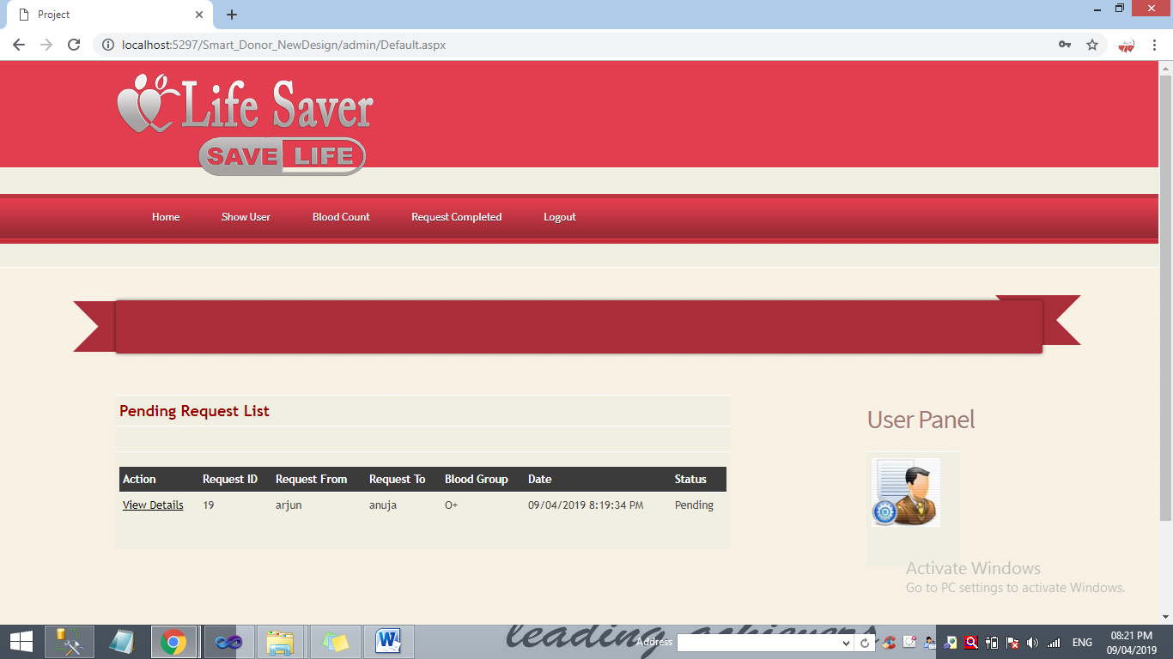

Screenshot: 5.1 (k)After Admin Login Page

**Blood Count**

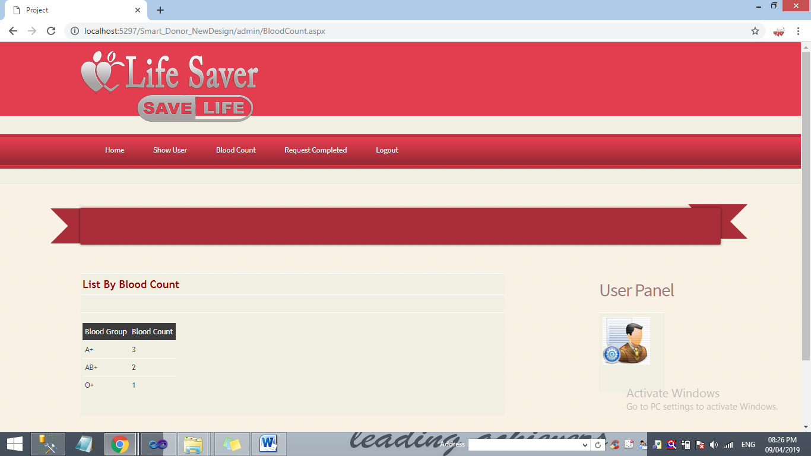

Screenshot: 5.1 (m) Blood Count Page

**5.2 Testing Approach-**

Software testing is an important technique for assessing the quality of a software product. Software testing is the process of analyzing a software item to detect the differences between existing and required conditions i.e. bugs and to evaluate the features of the software item*.* Software testing is an activity that should be done throughout the whole development process. There are various types of test each test type addresses a specific testing requirement.

**5.2.1 Unit Testing:**

Unit testing is the testing of individual hardware or software units or groups of related unit*.* Using white box testing techniques, testers (usually the developers creating the code implementation) verify that the code does what it is intended to do at a very low structural level. For example, the tester will write some test code that will call a method with certain parameters and will ensure that the return value of this method is as expected. Looking at the code itself, the tester might notice that there is a branch and might write a second test case to go down the path not executed by the first test case. When available, the tester will examine the low-level design of the code; otherwise, the tester will examine the structure of the code by looking at the code itself. Unit testing is generally done within a class or a component.

**5.2.2 Integrated Testing:**

Integration test is testing in which software components, hardware components, or both are combined and tested to evaluate the interaction between them. Using both black and white box testing techniques, the tester (still usually the software developer) verifies that units work together when they are integrated into a larger code base. Just because the components work individually, that doesn’t mean that they all work together when assembled or integrated. For example, data might get lost across an interface, messages might not get passed properly, or interfaces might not be implemented as specified. To plan these integration test cases, testers look at high- and low-level design documents.

**5.2.3 System Testing:**

Using black box testing techniques, testers examine the high-level design and the customer requirements specification to plan the test cases to ensure the code does what it is intended to do. Functional testing involves ensuring that the functionality specified in the requirement specification works. System testing involves putting the new program in many different environments to ensure the program works in typical customer environments with various versions and types of operating systems and/or applications. System testing is testing conducted on a complete, integrated system to evaluate the system compliance with its specified requirements .Because system test is done with a full system implementation and environment, several classes of testing can be done that can examine non-functional properties of the system.

**5.2.4 Program Testing:**

In this project program run satisfactory & data are tested correctly & tried properly with programs. Program testing checks for two types of error: syntax errors & logical errors. Where the sequence of instruction is traced to determine problem System testing is designed to uncover weaknesses that were not found in earlier tests. This includes forced system failure and validation of the total system, as it will be implemented by its user(s) in the operational environment. Generally, it begins with low volumes of transactions based on live data. The volume is increased until the maximum level for each transaction type is reached. The total system is also tested for recovery and fallback after various major failures to ensure that no data are lost during the emergency.

In system testing, it is check that the systems do their work properly or not. In our project, we test that if the user is registered then their data is saved in the database . And if the customer trying to access the system with wrong user id and password then the system generates the warning message. In system testing, when user request to login and after entering the username and password, the system test in the database file that the user information is exist or not.

**5.3 Implementation:**

Implementation simply means carrying out the activities described in the work plan. Project implementation or project execution is the phase where visions and plans become reality. This is the logical conclusion, after evaluating, deciding, visioning, planning, applying for funds and finding the financial resources of a project. The objective of implementation phase includes putting action plan into operation, achieving tangible change and improvements, ensuring that new infrastructure, new institutions and new resources are sustainable in every aspect.

The system that is going to be developed is smart blood donor. This is a web-based database application system that is to be used by the blood banks or blood centers as a means to advertise the nationwide blood donation events to the public and at the same time allow the public to make online reservation and request for the blood. The system keeps the record of all the donors, recipients, blood donation programs, rejected bloods. For internal works and activities intranet is used and for interaction with public internet is used. This project intends to computerize the blood and donor management system in a blood bank in order to improve the record management efficiency due to the grown size of records of data. Person who needs to donate blood may register in this application as he can modify their details by giving their login user name and password. The person who need blood donor then they can search and find blood donors by using our application. User can get brief details about their contact details including their location after accepting there request by admin. Donor and accepter both get the all details through SMS.

**6. CONCLUSION**

**6.1 Limitations of the System:**

* In this system, notification is not generated if someone sends a friend request to another person.
* The internet connection is required to use this web application.

**6.2 Future Scope of the Project:**

It is not possible to develop a system that makes all the requirements of the user. User requirements keep changing as the system is being used. Some of the future enhancements that can be done to this system are:

* As the technology emerges, it is possible to upgrade the system and can be adaptable to desired environment.
* Because it is based on object-oriented design, any further changes can be easily adaptable.
* Based on the future security issues, security can be improved using emerging technologies.
* Email gateway module can be added
* sub admin module can be added

**6.3 Conclusion:**

In this project user can request the donor for specific blood group. The admin can handled the user requests if admin confirm the given request then SMS will be sent on registered mobile number of user. Also user and admin can view the status of the request in the login panel. The person who need blood donor then they can search and find blood donors by using our application. User can get brief details about their contact details including their location after accepting there request by admin. Donor and accepter both get the all details through SMS. The user can make a call or message directly by using our application. The application can be further expanded by following the future Enhancements mentioned above.

**7. BIBLIOGRAPHY**

[1] [www.aspdotnet.com](http://www.aspdotnet.com)

[2] http://msdn.microsoft.com/en-us/vstudio/aa496123.aspx

[3] http://www.ezzylearning.com/technology.aspx?techid=1hg&q=asp-net

[4] <http://www.w3schools.com/aspnet/default.asp>

[5] http://msdn.microsoft.com/en-us/library/vstudio/bb400852(v=vs.90).aspx

[6] http://www.w3schools.com/aspnet/webpages_intro.asp

[7] <http://www.w3schools.com/aspnet/aspnet_intro.asp>

[8] <http://www.functionx.com/sqlserver2005/Lesson01.htm>

[9]<http://www.ibm.com/developerworks/web/library/wa-ajaxintro1/index.html>

[10] <http://en.wikipedia.org/wiki/Asp.NET>

[11] Professional ASP.NET 2.0 By Bill Evjen, Srinivas Sivakumar